|  |  |
| --- | --- |
| **Assignment Case** |  |
| COMP6178  Introduction to Programming |
| **Computer Science** | **O213-COMP6178-LO03-02** |
| ***Valid on*** *Odd Semester Year 2020/2021* | **Revision 00** |

1. Seluruh mahasiswa tidak diperkenankan untuk:

*All students are not allowed to:*

* + 1. Melihat sebagian atau seluruh jawaban mahasiswa lain,

*Seeing a part or the whole answer from other student*

* + 1. Menyadur sebagian maupun seluruh jawaban dari buku,

*Adapted a part or the whole answer from the book*

* + 1. Mendownload sebagian maupun seluruh jawaban dari internet,

*Downloading a part or the whole answer from the internet,*

* + 1. Mengerjakan soal yang tidak sesuai dengan tema yang ada di soal,

*Working with another theme which is not in accordance with the existing theme in the matter of the case,*

* + 1. Melakukan tindakan kecurangan lainnya,

*Committing other dishonest actions,*

* + 1. Secara sengaja maupun tidak sengaja melakukan segala tindakan kelalaian yang menyebabkan hasil karyanya berhasil dicontek oleh orang lain / kelompok lain.

*Accidentally or intentionally conduct any failure action that cause the results of the project was copied by someone else / other groups.*

1. Jika mahasiswa terbukti melakukan tindakan seperti yang dijelaskan butir 1 di atas, maka **nilai mahasiswa** yang melakukan kecurangan (menyontek maupun dicontek) akan di – **NOL** – kan.

*If the student is proved to the actions described in point 1 above, the score of the student which committed dishonest acts (cheating or being cheated) will be “Zero”*

1. Perhatikan jadwal pengumpulan jawaban, segala jenis pengumpulan jawaban di luar jadwal tidak dilayani.

*Pay attention to the submission schedule, all kinds of submission outside the schedule will not be accepted*

1. Persentase penilaiaan untuk matakuliah ini adalah sebagai berikut:

*Marking percentage for this subject is described as follows:*

|  |  |  |
| --- | --- | --- |
| **Tugas Mandiri**  *Assignment* | **Proyek**  *Project* | **UAP**  *Final Exam* |
| 40% | - | 60% |

1. Software yang digunakan pada matakuliah ini adalah sebagai berikut:

*Software will be used in this subject are described as follows:*

|  |
| --- |
| **Software**  *Software* |
| Java 8  Eclipse 2020.6 |

## Ekstensi file yang harus disertakan dalam pengumpulan tugas mandiri dan UAP untuk matakuliah ini adalah sebagai berikut:

*File extensions should be included in assignment and final exam collection for this subject are described as follows:*

|  |  |  |
| --- | --- | --- |
| **Tugas Mandiri**  *Assignment* | **Proyek**  *Project* | **UAP**  *Final Exam* |
| JAVA, CLASS | - | JAVA, CLASS |

## Soal

*Case*

**Mobail Lejen**

**Mobail Lejen** is one of the most popular mobile game in epStore. This game allows the user to make their own hero. There are **3 roles hero** that you can choose in this game such as **Tank**, **Range**, **Magic**. As a programmer, you are asked to make a program for this game.

* The program consists of **3 menus**:

1. **View Heroes**
2. **Add Heroes**
3. **Exit**

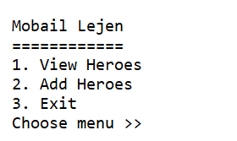

* If user **choose** menu **1** ("**View Heroes**”), then the program will:
* **Display** message “**There is no hero added**” if there is **no data**.

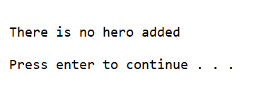

* If there is data, the program will **display** all the heroes’ data such as **Hero** **Role**, **Name**, **Skill**, **HP**, **Power**.

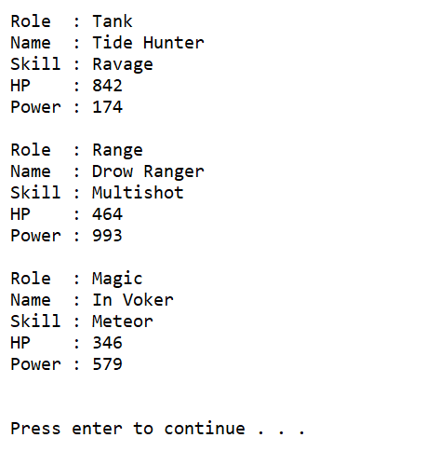

* If user **choose** menu **2** “**Add Heroes**”, the program will:
* Ask user to **choose** the **role of the hero**. Validate that the **role of the hero** **must be either** “**Tank**”, “**Range**”, “**Magic**” (**case sensitive**)

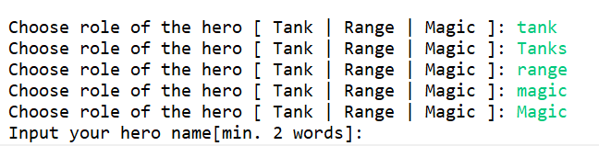

* Ask user to **input** the **name** of the hero. Validate that the **name** of the hero **must have at least 2 words**.

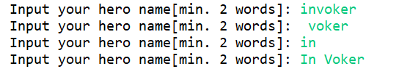

* If the **role** of user hero is “**Tank**”. Validate the **skill** of the hero **must be either** “**Dismember**”, “**Ravage**” or “**Warpath**” (**case sensitive**).

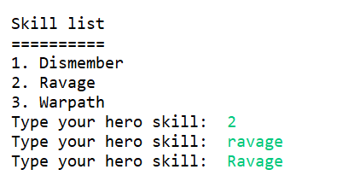

* If the **role** of user hero is “**Range**”. Validate the **skill** of the hero **must be either** “**Lucent Beam**”, “**Powershot**” or “**Multishot**” (**case sensitive**).

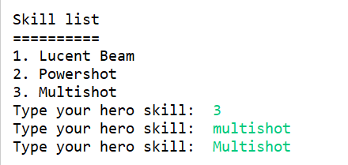

* If the **role** of user hero is “**Magic**”. Validate the **skill** of the hero **must be either** “**Cold Snap**”, “**Meteor**” or “**Tornado**” (**case sensitive**).

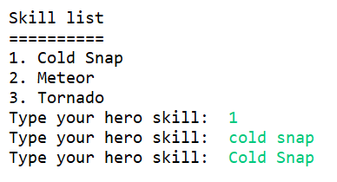

* The **initial HP** of **all heroes** is **100.**
* Determine the **additional HP** of the heroes based on this table:

|  |  |
| --- | --- |
| Hero Role | Additional HP |
| Tank | Random number from 500 – 1000 |
| Range | Random number from 100 – 500 |
| Magic | Random number from 100 – 500 |

* **Calculate** the **Final** **HP** based on this formula:

**HP = Initial HP + Additional HP**

* Determine the **Power** of the heroes based on this table:

|  |  |
| --- | --- |
| Hero Role | Power |
| Tank | Random number from 100 – 500 |
| Range | Random number from 500 – 1000 |
| Magic | Random number from 500 – 1000 |

* Save the **heroes data** in a **Collection** (**ArrayList / Vector / Array**).
* If user choses **menu 3** (“**Exit**”), then the program will be closed.

**Good Luck**